3.15: a) Solving Eq. (3.17) for 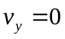, with 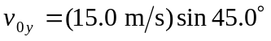,

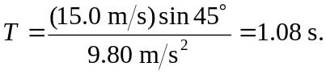
b) Using Equations (3.20) and (3.21) gives at 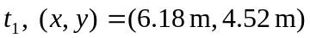: .

c) Using Equations (3.22) and (3.23) gives at for velocities, respectively, of 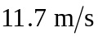 @ 24.8°, 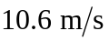 @ 0° and @ −24.8°. Note that 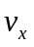 is the same for all times, and that the y-component of velocity at is negative that at.

d) The parallel and perpendicular components of the acceleration are obtained from

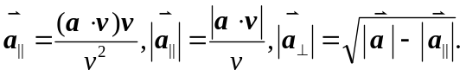
For projectile motion, 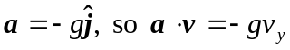, and the components of acceleration parallel and perpendicular to the velocity are 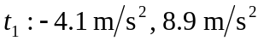. 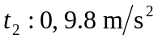. 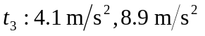.
e)
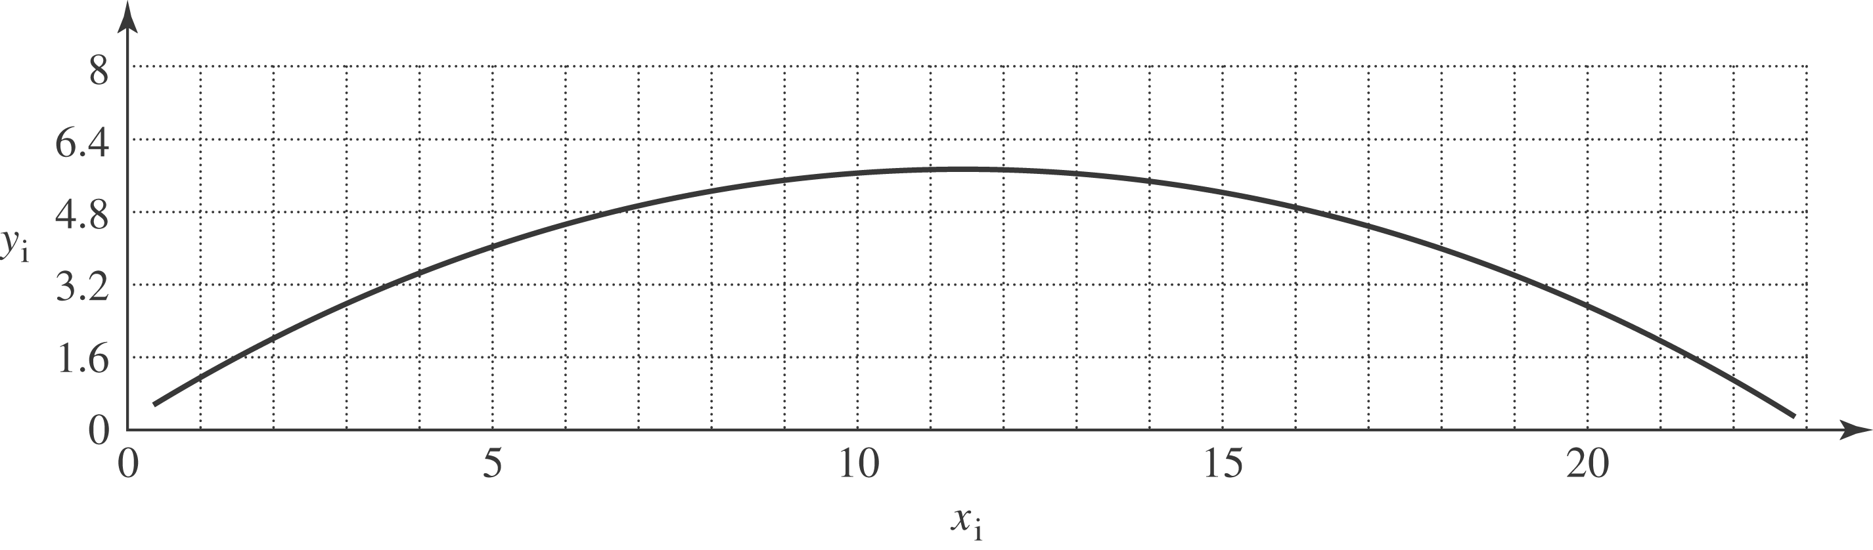
f) At t₁, the projectile is moving upward but slowing down; at t₂ the motion is instantaneously horizontal, but the vertical component of velocity is decreasing; at t₃, the projectile is falling down and its speed is increasing. The horizontal component of velocity is constant.

